A quick guide for supporters: responding to the Home Office Immigration Plan
You will have seen from our newsletter and the press that the Government has opened a public consultation on their 'New Plan for Immigration’. The consultation closes on 6th May 2021. However, we will continue to campaign to increase awareness about the impact of these proposals on asylum seekers and refugees in Nottinghamshire.
You can find the full plan here.
In summary the plan proposes:
A two-tier system. Those that arrive through unlawful means will not obtain full refugee status or family reunion rights. Their status will be regularly reviewed, and they may be returned. Asylum support may be reduced. This is modelled on the Danish system which has been condemned by refugee and human rights advocates. Denmark recently began returning Syrian refuges to Damascus and the prime minister has a vision to have zero asylum seekers in Denmark.
Reintroduction of accommodation centres. We know that there are many cases of compensation arising from victims of torture being unlawfully detained. We know that detention has a devastating impact on the mental health of vulnerable asylum seekers. We are also aware of the terrible conditions in former army barracks and the enormous profit being made by private sector detention operators. Detention should only ever be a measure of last resort (as indicated in international guidelines).
Increasing penalties for unlawful entry and assisting unlawful entry. It has long been acknowledged that there is no lawful method of entering the UK to seek asylum. Carriers’ liability and visa regimes make it impossible for an asylum seeker to travel safely to the UK to make an asylum claim. Resettlement is only an option for a tiny number of refugees and cannot possibly apply to all those who need sanctuary. Increasing penalties will only profit smugglers who will be able to charge higher fees for more dangerous routes. They are not a deterrent and will lead to more deaths.

Preventing abuse of asylum appeals. 73% of asylum claimants have been in the asylum system for more than a year. This causes immense hardship to those desperate to rebuild their lives. The situation has deteriorated markedly since the UK abandoned the 6-month target for straightforward asylum claims in 2019. This delay is not the fault of asylum seekers and cannot be attributed purely to the marginal increase in asylum applications in 2019. If it is possible for France, Germany, and Spain to aim for compliance with a six month target it should also be achievable in the UK- a country with fewer asylum applications.
43% of asylum appeals are successful suggesting a significant problem with Home Office decision-making.

Child asylum seekers and family reunion The two-tier system proposed in this Plan will have a devastating impact on the majority of unaccompanied children who arrive in the UK via irregular routes Under this plan it is unlikely that children who arrive in the UK will be entitled to anything more than a temporary reviewable form of protection which will provide no security or certainty for their future– a measure which will inevitably be in conflict with the Home Secretary’s duty to safeguard the welfare of the children.
The closure of both the Dublin family reunion route and the Dubs scheme is already having a devastating impact on the most vulnerable of the asylum-seeking community.
To be clear, if these proposals are enacted they will prevent asylum seekers from securing protection in the United Kingdom. They will force more people into destitution and destroy the lives of the most vulnerable. They will be more expensive as tax-payers money is increasing diverted towards private security operators. WE MUST ACT.
WHAT WE HAVE DONE
A group of 8 organisations in Nottingham have presented their collective response to local MPs and local media. You can read our response here. Each organisation has also produced their own response which is tailored to the experience of their organisation. NNRF’s response can be found on our webpages here.
WHAT YOU CAN DO – respond, engage, challenge
Although we have grave concerns about the very short timescale for the Home Office to respond we must act in good faith and ensure that the voices of the most vulnerable are heard. We must then continue to campaign as a Bill is likely to come before parliament in the next year.
- RESPOND
You can register to respond to the consultation (registration takes 30 seconds). You can then submit your answer to the questions before the deadline of 6th May.
To take part in the consultation, you will need to register, click the respond button
You’ll be invited to register with an email address. Once you’ve created your account, you will be given three ways to take part.
Once you’ve registered, you can enter the survey as a member of the public.
You can answer questions on each section of the plan of just focus on those questions where you have the most knowledge.
However, we would strongly encourage you to answer the first question. We would ask our supporters to respond by clicking E for the reasons provided above.
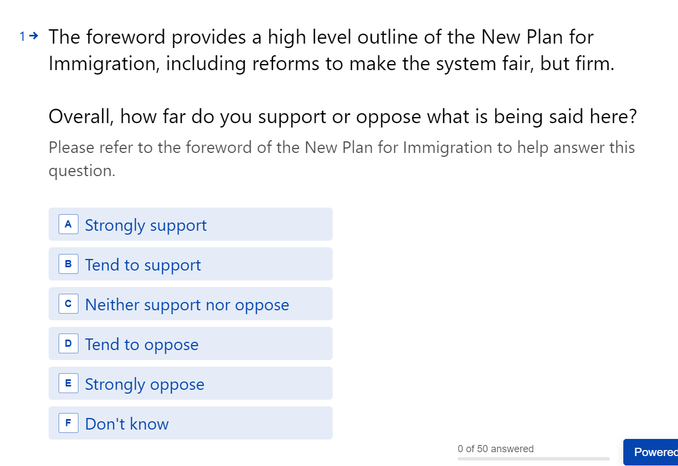

We would also recommend that you answer Q,45 where you are able to enter your own views as free text.

- ENGAGE

We would urge you to contact your local MP, particularly if you live in the county. Nottingham city Labour MPs have been very encouraging, but they are clear that the strength of the government’s majority will make it difficult for them to influence the government’s approach. If you are a constituent of a conservative MP, please write to them or ask for a meeting, they have an obligation to hear your views.

- CHALLENGE

Keep an eye on local media. Try to challenge misleading stories yourself or contact journalists/broadcasters and refer them to our Nottingham response. We are happy to speak to the media if you do not feel comfortable doing this.

Tell your friends, family, and work colleagues. We must challenge the narrative that asylum is a waste of tax-payers money and a threat to public safety and security. You can emphasise:

- There is a humanitarian duty to accommodate and support asylum seekers
- There is a right to seek and enjoy asylum under the Universal Declaration of Human Rights 1948
- The UK does much less than comparable sized European countries (Inc. France, Germany, and Spain)
- The UK has a history of compassion and tolerance
- Over half of asylum seekers will obtain refugee status i.e., they have demonstrated a well-founded fear of being persecuted.
- 0.4% of the UK population are refugees or asylum seekers (UNCHR statistics)
- The cost could be reduced by having faster and better decision making in the Home Office and by allowing asylum seekers to work.

