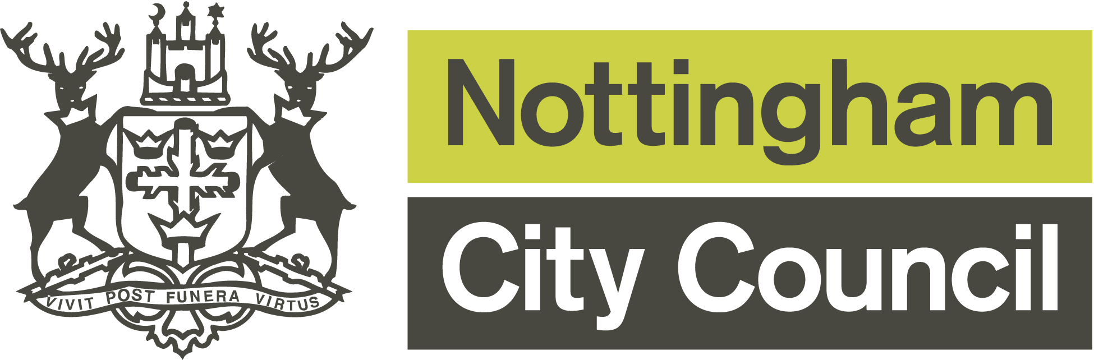

Refugee & Asylum Seeker
Communities of Identity Small Grants Scheme
Guidance

Nottingham & Nottinghamshire Refugee Forum (NNRF) is the lead organisation of the ‘Refugee and Asylum Seeker’ Consortium. The Consortium is comprised of 13 community organisations that represent and work with refugees and asylum seekers in Nottingham. Funding has been allocated to a Small Grants Scheme in this current financial year 2019-20.
This funding aims to help small grass roots groups that work with refugee and asylum seekers and their communities, and who have ideas for projects or activities that will either directly benefit individuals from these communities or help build stronger community organisations.
The funding (up to £750) will support the following types of development projects:

- Activities that help community groups to develop their capacity – e.g. hiring rooms for meetings; volunteer expenses to run activities or support the development of their organisation.
- Activities that build skills & confidence – e.g. skills training workshops for community members and volunteers; short courses to help people develop skills in a specific work area or interest.
- Volunteering projects that can help increase the capacity of small groups and their communities and enable peer support activities and leadership skills to be developed.
- ESOL & conversation classes to enable community members to integrate into the wider community and access local services.
- Young People’s Projects to enable them to be active citizens.
- Young People’s Projects to develop stronger intergenerational relationships and support the transition from child to adult.
- Providing support, information and guidance for individuals’ basic needs, enabling them to access basic levels of support from local providers.
- Activities that raise awareness of the issues faced by refugees and asylum seekers and promote positive dialogue to increase community cohesion.

Training and other support for the group may also be offered by the Consortium.

If you have an idea for a project that doesn’t fit into any of the above categories then please contact us to discuss it further before writing an application.

Who can apply for funding?

Small voluntary & community groups/organisations with an income of less than £10,000 or groups of people that have ideas for projects or activities related to the headings above.

Groups or projects that are successful but do not have governing documents such as a constitution, accounts or relevant policies, can ask NNRF (or another suitably constituted organisation in the Consortium) to hold the funds on their group’s behalf. This will mean that the organisation holding the grant will be responsible for making payments for items in your budget following the receipt of appropriate invoices.
If your group is constituted, has accounts and all the relevant policies then you will need to provide your governing documents and your most recent annual accounts with your application form.
What will the funds pay for?
The costs must relate directly to the activity you are providing. Examples include:

Rent: The cost of using premises to deliver your project or to hire a venue for an event.

Equipment: Purchase of materials and / or hire of equipment to deliver your project

Publicity: Production of a leaflet or newsletter to advertise the activities you are undertaking.

Expenses: Travel / parking / food for volunteers delivering activities or supporting your group.

Training: Courses for volunteers, community members or staff.

Admin: Insurance and membership costs, general stationery for running the activity.

Support: Additional specific support that may be needed (e.g. translation costs).

What will the funds not support?
The fund cannot be used to support:
- Statutory organisations, private businesses or profit-making activities.
- Activities where the primary purpose is to promote religious beliefs or where some people are excluded on religious grounds.
- Political groups or groups promoting political activities.
- Activities that take place outside the City Council boundary.
- Costs you owed or promised to pay before your application was approved (retrospective costs).
- Funding to give to other individuals or groups.
- Costs associated with foreign travel.
- Organisations already funded through the COI grant process.

When can I apply?
The next closing date for applications is Monday 2nd September 2019. The panel will make a decision on Thursday 3rd October.
All projects need to be completed within 9 months of being awarded a grant.

Completing the application form
The application form should be straightforward to complete. Just answer the questions to the best of your ability explaining what you’re trying to achieve. Make sure that the information you write is easy to understand, so that the people who read your form know what you’re trying to do for your community.
Sources of help
Any queries regarding the process, project ideas, further support, other training opportunities, you can telephone or e-mail:

Debbie Royle – COI Partnership Development Coordinator
Tel: 0115 9601230
E-mail: Debbie.royle@nottsrefugeeforum.org.uk

OR

NCVS Group Support:
Tel: 0115 9348405
E-mail: groupsupport@nottinghamcvs.co.uk

Where to send your applications
By email to: Debbie.royle@nottsrefugeeforum.org.uk

By post to:
Debbie Royle
Partnership Development Coordinator
NNRF, The Sycamore Centre, 33a Hungerhill Road, Nottingham, NG3 4NB.

What happens next?
Once we have received your application, the Partnership Development Coordinator will contact you to arrange to meet and discuss your application, and will then pass on your application to the Steering Group Panel. The Steering Group (a panel of assessors with experience of working with refugee and asylum seeker communities) meets 4 times a year to assess any applications and will make a decision on your application. We will let you know whether your application has been successful or not by e-mail or letter shortly after the Panel meeting.
If your application is not funded we can give you positive feedback to help you understand why we made this decision. This will help you work towards making a better application in the future or better applications to other funders.
If you are successful then as soon as your project has finished you will need to write and send us a short monitoring report describing how the project went, how many people benefited, a list of expenditure and receipts. A monitoring form will be sent to you if your application is successful and will need to be returned within 6 weeks of the project or activity having been completed.

